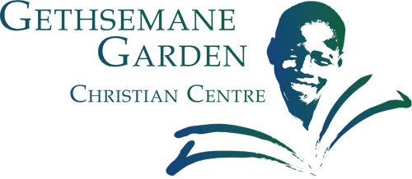
Join us for the

2nd Annual GGCC Golf Classic

When: Tuesday, September 22, 2015 from

Time: 1:00 PM to 6:00 PM
Where: The Golf Club at Ballantyne

10000 Ballantyne Commons Parkway, Charlotte, NC 28277

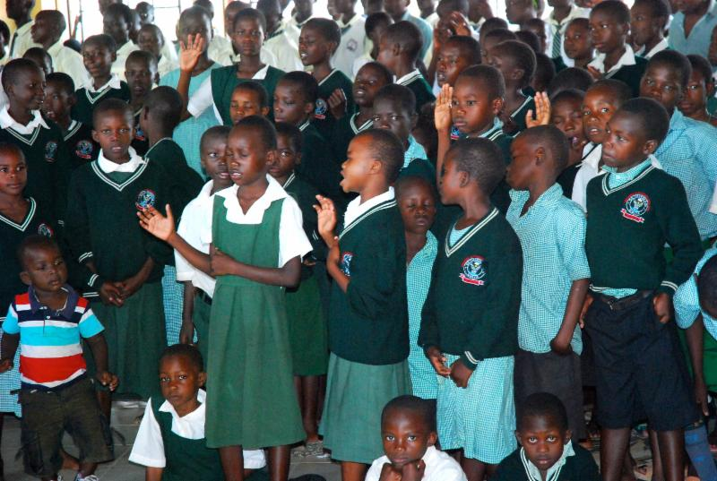
You can make a difference in the life of an orphaned child!
All proceeds benefit GGCC Kenya, a Christian boarding school for 630+ HIV/AIDS orphans! GGCC provides, food, clothing, shelter, medical care, and a Christian education for these students. Your playing or sponsoring will make an enormous impact on these student’s lives and futures.

REGISTER TODAY ONLINE AT:
www.ggcckenya.com
Event details and registration information can be found on the website. Individual golfer, foursomes, and sponsorships are available!
Registration Includes: Golf/cart fees, range balls, box lunch, gift bags, awards ceremony, and door prizes.
Golf Format: Captain's Choice and several special/fun contests.
"Religion that God our Father accepts as pure and faultless is this: to look after orphans and widows in their distress and to keep oneself from being polluted by the world." James 1:27

